Asia-China-Knife Money-Type 1, Qi Knives-400-220 BCE.

Harthill 4.2

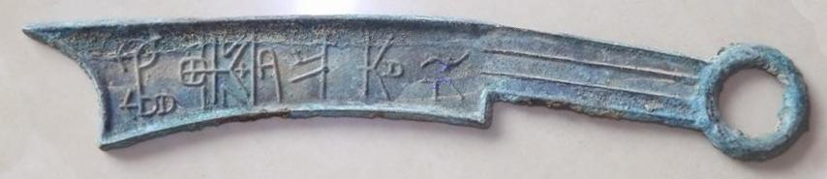 SHAPE \\* MERGEFORMAT 